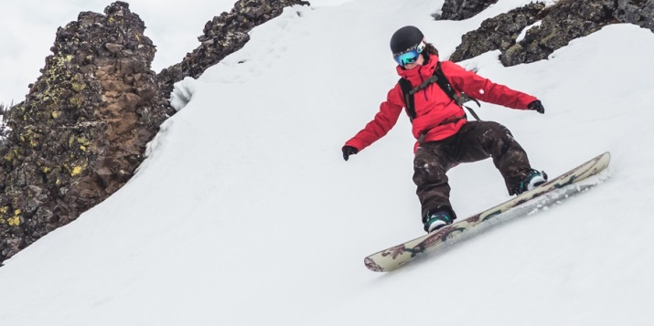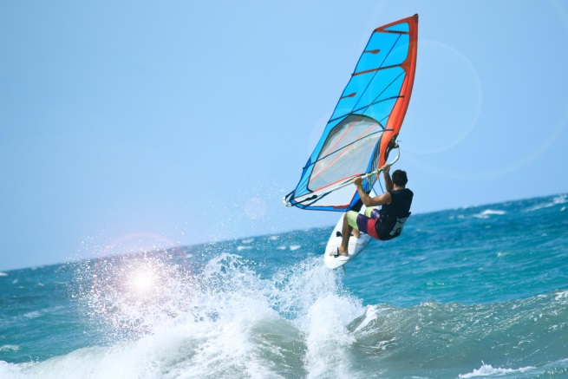**Project: comparing sports - adjectives**

windsurfing

more

snowboarding

1. Windsurfing is faster than paddle-boarding.
2. Weather for snowboarding is colder than for windsurfing and paddle-boarding.
3. Windsurfing is more expensive than paddle-boarding.
4. Windsurfing is funnier than paddle-boarding.
5. You need more clothes for snowboarding than for paddle-boarding.

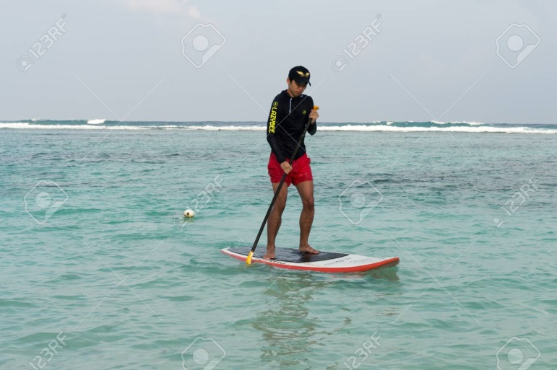________________________________________________

paddle-boarding

The most

1. Paddle-boarding is the easiest to learn.
2. Windsurfing is the most difficult to learn.
3. Windsurfing is the fastest of them.
4. For snowboarding you need the coldest weather.
5. Paddle-boarding is the slowest of them.